

American International University Bangladesh
SOFTWARE ENGINEERING
Section-D
Group-7
Lab Work-3
Faculty-RAHNUMA TASNIM
Submitted By- MONJILA KABIR MEGH (22-47597-2)

Project Title: Online Food Ordering and Delivery System

Students Name | Students ID
M.M.GOLAM HAFIZ | 22-48058-2
SAFIA AKTER SIMI | 22-48008-2
MONJILA KABIR MEGH | 22-47597-2
MD. MEHRAN HOSSEN SHIHAB | 21-44905-2

Project Name: Online Food Ordering and Delivery Management System
All the requirements:
- User Account and Profile Management
- Menu Display and Product Catalog
- Custom Pizza Builder
- Location-Based Store Finder
- Ordering and Payment
- Live Order Tracking
- Customer Feedback and Rating
- Admin Dashboard for Store Management
- Subscription-Based Ordering
- In-App Chat Support
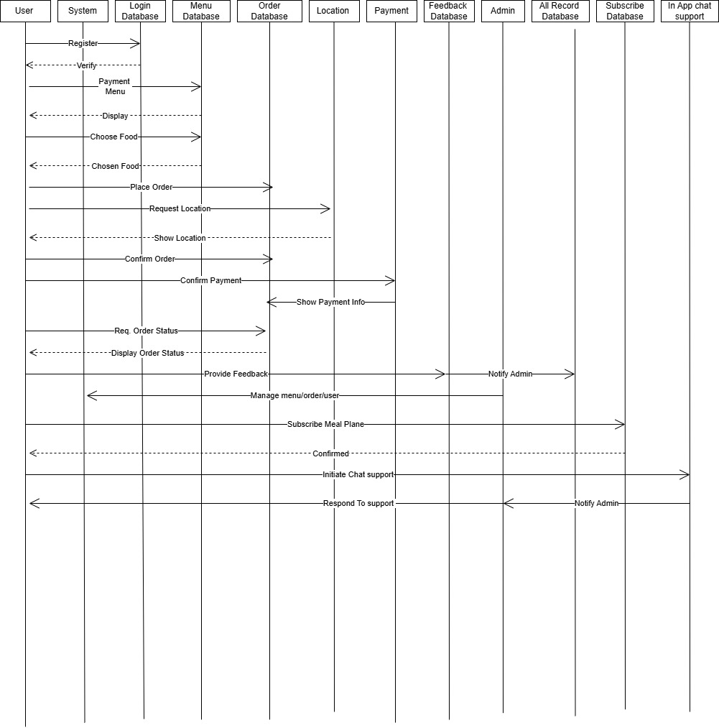
Sequence Diagram:

